How To Lace Your Skates
You can help your child learn to skate if you fit and lace the boot properly. Make sure your childs foot is is all the way in the boot. The heel should be kicked back, so any extra room is in the toe.
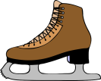 Figure Skates
Once foot is in the skate, pull laces snug that are laced through the holes.
Cross, pull and hook laces. Continue crossing, pulling, and hooking until you have reached the top of the skate. Laces should be snug at the toes, tight across the ankle, and snug again to the top of the boot. Do not skip any hooks.
If laces are too long, lace back down the hooks and tie at the ankle.

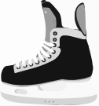 Hockey Skates
Hockey skates require more stength to tighten than figure skates.
Once the foot is in the skate, cross and lace loosely through all the holes. Lace all the way to the top of the skate, do not skip any holes.
Now go to the bottom of the laces and begin tightening, working your way up the skate to the top and tie. Laces should now be tight or snug, not loose.
If laces are too long, double knot. Do not wrap around the ankle.

